Zomato Restaurants Analysis

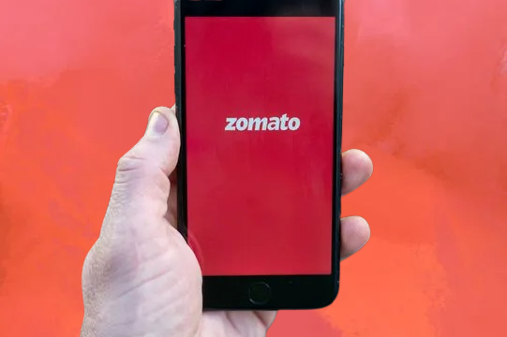

Spreadsheet Project

PROBLEM STATEMENT :

You are hired as a consultant data analyst by Zomato where the team is looking for expansion and opening more restaurants. Your task is to develop strategies/suggestions for opening newer restaurants.

1.What is the total no. of tables present in the data?

In the given provided data set, there are 2 tables (worksheets) are present by the name Raw Data and Country Description.

2.What is the total no. of attributes present in the data?
Attributes refers to columns in Excel so in the data set there are total 20 columns present.

3.How many categorical columns are there in the data? [Search about categorical and continuous data, and try to answer this question]
Categorical Columns refers to the columns containing the labels or categories that are not measurable or can’t be quantify. Example: Gender, City, Names, Department etc. Basically, Categorical columns are non-numerical data.
So in the given data set, There are 14 Categorical Columns.Below is the list of Column Names:

1.Restaurant ID | 2.Restaurant Name
3. Country Code | 4. Country
5.City | 6. Address
7. Locality | 8.Locality Verbose
9.Cuisines | 10. Currency
11. Has_Table_booking | 12. Has_Online_delivery
13. Is_delivering_now | 14. Switch_to_order_menu

4.The data consists of some inconsistent and missing values so ensure that the data used for further analysis is cleaned.
To clean the data I have used following methods:
HANDLING MISSING DATA
Since some missing values were found in the cuisine’s column, all of them belonged to restaurants located in the United States of America. Therefore, the blank entries in the cuisine’s column were replaced with the most common cuisine in the U.S., which is Mexican. First, I applied filter on the cuisine column and total of 6 cells were blank so I manually filled those cells.
REMOVING DUPLICATES
I checked the data set for any duplicate records using the Restaurant Name and Address columns. After verifying through the Data tab and using the “Remove Duplicates” option, I found that there were no duplicate entries in the data set.
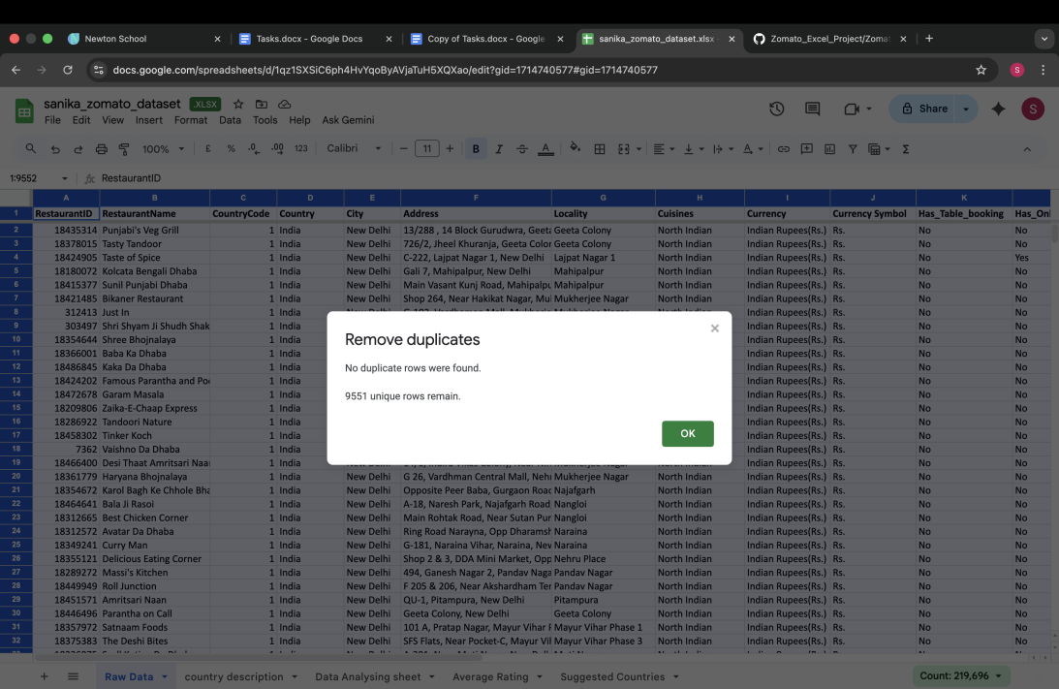

REMOVING UNNECESSARY COLUMNS
While exploring the data set, there were column those were of no use like latitude, longitude and locality verbose. So, to avoid redundancy and make data look cleaner. I removed those columns from the data set.

FORMATTING DATEKEY COLUMN
The column Date key Opening in the sheet Raw Data was not set in proper date format. So, to format the column, I have used formula
=DATEVALUE (SUBSTITUTE (T2,” _”,”- “))
This formula helped me to change the format from 2013_9_18 to 18/09/2013.After formatting the date key column.I created 3 different helper column to separate year, month and date. I used split to text function to separate the year, month and date respectively.
CURRENCY CONVERSION TO INR
The data set contains restaurants from different countries along with different currencies. So, for comparative analysis, I converted all the cost values into INR. So, I created the new column in country description sheet by name Rate into INR. Here is a currency conversion.
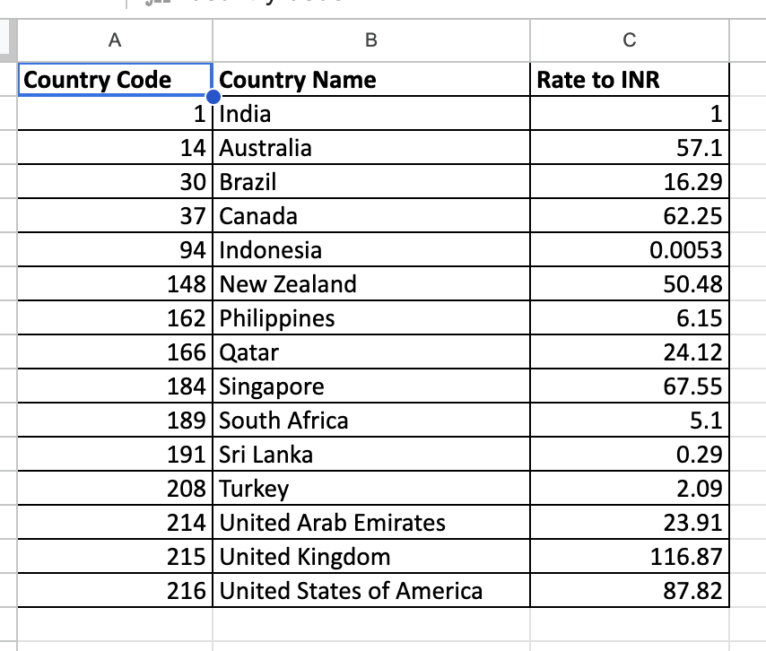
Along with this, I have standardized the Average Cost for Two across different countries into a single comparative unit i.e. INR, for consistent analysis and visualization. I created a column in Raw data sheet by name Average_cost_for_two_INR. I have filled this column using VLOOKUP, where I utilized the Rate to INR column from the other sheet, and formula is as given below
=Q2*(VLOOKUP (C2,'country description’! A:C,3, FALSE))
After apply the formula when all the values were fetched, I used format tab to apply Rupees symbol to the filled values.

5.Using the Lookup functions, fill up the countries in the original data using the country code.
For this task, I have used VLOOKUP Function approach in following manner.
At First, I created new column called Country besides Country code column in Raw Data Sheet and to fill that particular column. I used VLOOKUP in reference with another column from Country description sheet naming Country code. The formula which I used is =VLOOKUP (C2,’Country Description’! A:C,2, FALSE). This function checks Country code in each row and retrieves the matching country name from the lookup table.
Here, C2 is the lookup value i.e., is Country code selected for searching.
‘Country Description’! A: B is the lookup array in which the value can be found and 2 is the column number.
FALSE is written to match exact value.

6.Create a table to represent the number of restaurants opened in each country.
For this task, I used Pivot Table to represent the number of restaurants opened in each country by selecting the entire data from Raw Data Sheet, then clicking on Insert tab which shows the option for Pivot Table.
After selecting the option, the option to select the sheet and data range shows up. In which I entered sheet range and a sheet name ‘Data Analyzing Sheet’! A1, where I want to create the pivot table.
ARRANGING THE DATA IN PIVOT TABLE :
Dragged Country into rows field and Restaurant ID into Values. Also, changed value settings to COUNT of Restaurant ID to get number of entries.
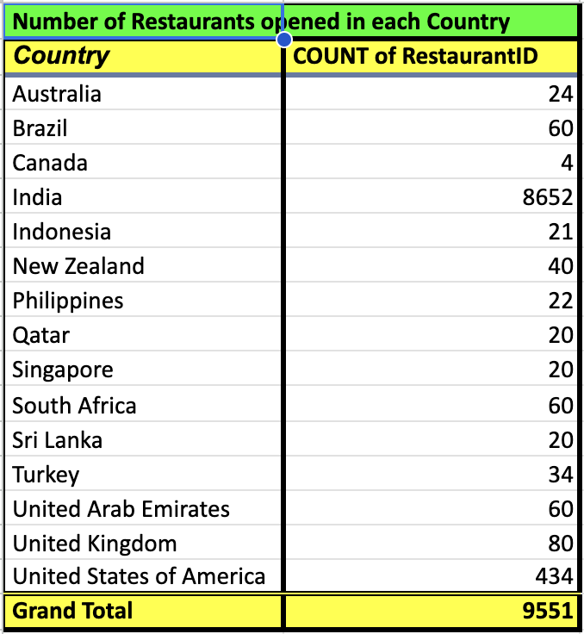
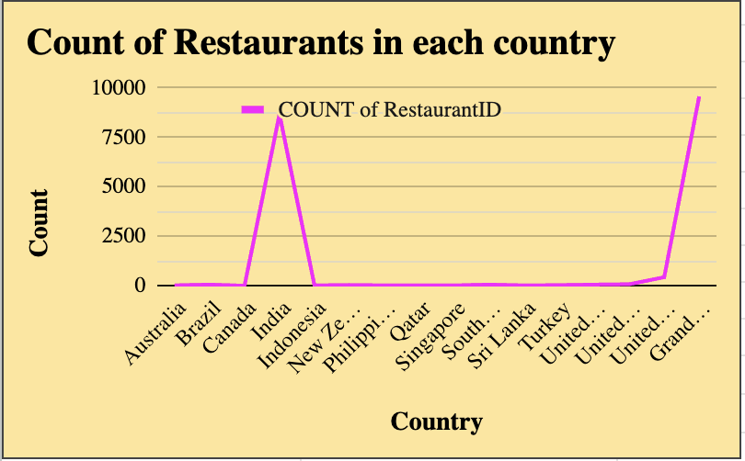
Pivot table in Data Analysing Shee
7.Also, the management wants to look at the number of restaurants opened each year, so provide them with something here.
For this, my approach is to use a Pivot Table,
1.I selected the entire updated data set
2.Choose Insert Pivot Table
3.Created the Pivot Table in the same worksheet i.e. (Data Analysing Sheet).
ARRANGING THE DATA IN PIVOT TABLE : First, dragged Year into the Rows area and Restaurant ID into the Values area. Set aggregation to Count to count restaurant openings.
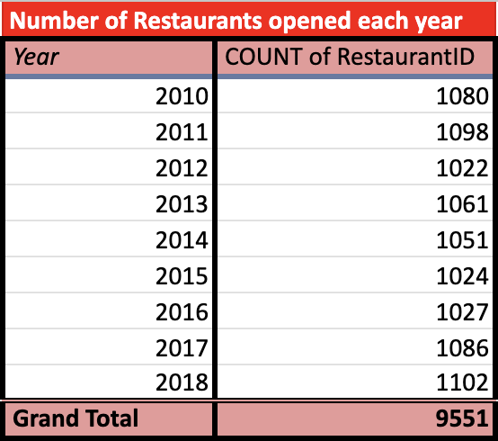
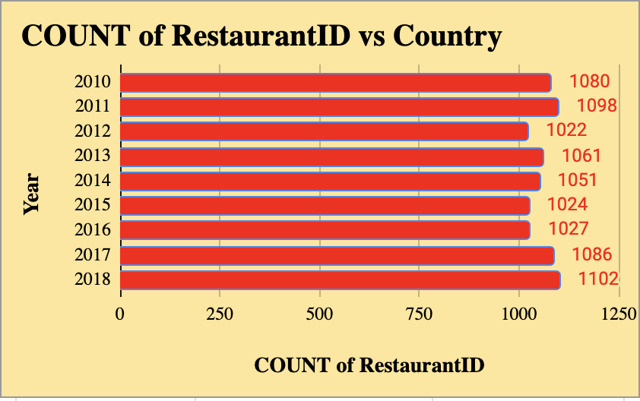
Pivot table in Data analysing sheet

8.What is the total number of restaurants in India in the price range of 4?
To find out how many restaurants in India belong to Price Range 4, which represents the higher-end pricing category, I used the Filtering feature. This allowed me to apply multiple conditions and filter the data set efficiently, without the need for a Pivot Table.
I applied the filter on Country and Price Range column and selected the conditions, after getting the updated data the count of entries were given below which was 388.
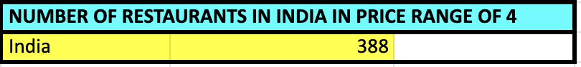

9.What is the average number of voters for the restaurants in each country according to the data?
I analyzed the average voter count per country using a Pivot Table.
I selected the cleaned data set and went to Insert → Pivot Table, placing it in the existing worksheet titled Data Analyzing Sheet.
In the Pivot Table, I dragged “Country” into the Rows field and “Votes” into the Values field, then changed the default aggregation from Sum to Average by right-clicking and selecting Summarize Values By → Average.
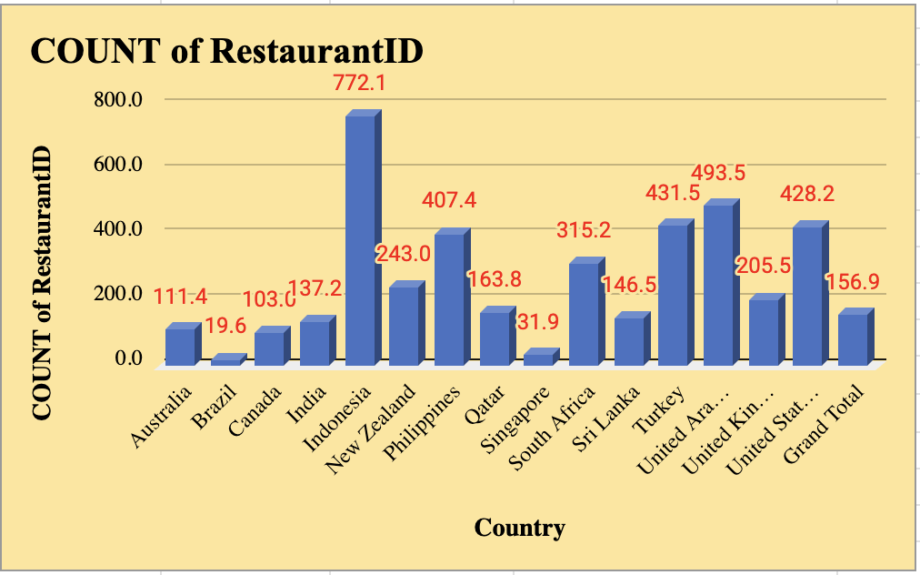
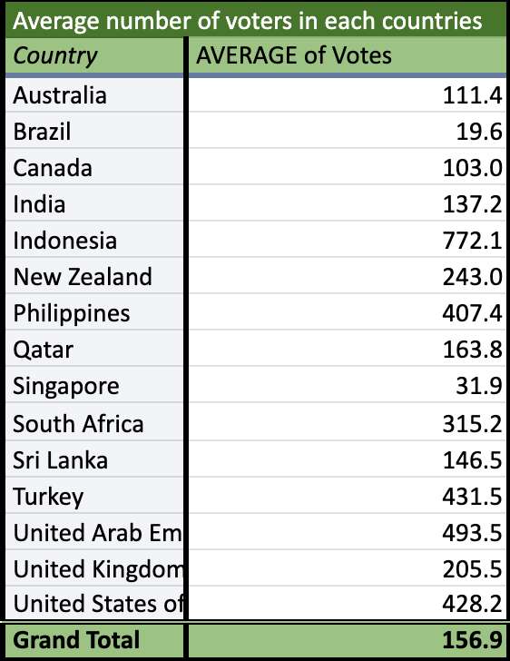
Pivot table in Data analysing sheet

10. Calculate the average rating for all the restaurants that have price range < 4 and provide online delivery. Use only the “IF” function, Logical Operators, and Aggregation functions to solve this problem. [Note: Don’t use Conditional aggregation in this question.]
To carry out this objective, I created an another worksheet by name Average Rating for better understanding.
To fetch out the average rating which also fulfil two other conditions as well i.e. the price range should be less than 4 and the restaurant must provide online delivery. I have used IF function with combining logical operators. The Average was then applied for calculating the average rating of restaurants fulfilling both criteria.
The formula which I used is :
=Array Formula(AVERAGE(IF(('Raw Data'!O2:O9552<4)*('RawData'!L2:L9552="Yes"), 'Raw Data'!S2:S9552)))
11.Using Conditional formatting highlight the rows of restaurants that are located in the countries or cities that you’ve suggested to the management for opening new restaurants.

To highlight potential restaurants for opening new restaurants, I have used conditional formatting that meet all the criteria :

- The restaurants should have an average rating of 3.5 or higher which shows higher customer engagement and satisfaction.
- The restaurants that is appearing several times in data set showing higher visibility and popularity among the area.
- The restaurants is located in the countries with less competition and where customer engagement is more.

To support my answer I created a different table which shows the country name which I am suggesting to the management along with the count and average rating.

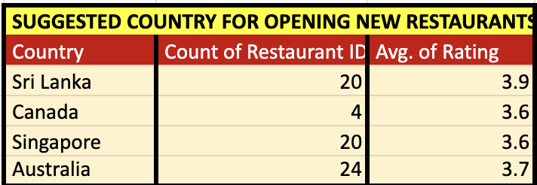

I applied conditional formatting and highlighted the countries in sheet name Suggested Countries. The logic for conditional formatting is given below :

=OR($A10="Australia", $A10="Philippines", $A10="Canada", $A10="Sri Lanka", $A10="Indonesia", $A10="Qatar", $A10="Singapore")

12.Create a new customized price column that consists of the abbreviation/symbol of the currency along with the Average_cost_for_two value. [Use string operations to do this task]
I created a new currency symbol column besides Currency column in Raw Data sheet.
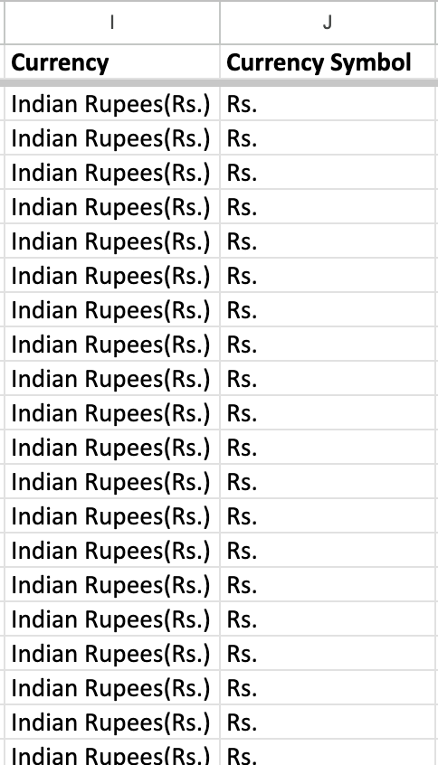
To extract only the currency symbol from the Currency Column, I used the below given formula
=IFERROR (MID (I2, FIND ("(“, I2) +1, FIND (")”, I2)-FIND ("(“, I2)-1),"")
This formula extracted the symbol based on value from I column. Along with that I created another new column i.e., Average_cost_for_two_INR. Here I used VLOOKUP to fetch the value from Country description sheet and then calculating the value based on country.
I have made the column static so that the symbol is preserved and ready for dashboard display.

13.How can you create an array formula in Excel or Google Sheets to count the number of restaurants listed that do not offer online delivery, are in the lowest price range, and have an average cost for two people less than or equal to 250 Indian Rupees?
In this objective, there are three conditions that must be fulfilled that are :
- No online delivery
- Lowest price range (price range =1)
- Average cost for two <= 250 INR.
And we have to count the restaurants which fulfils all the three conditions.So I have used this formula to extract the number.
=ARRAYFORMULA (SUM (('Raw Data'!L:L = "No")*('Raw Data'!O:O = 1)*('Raw Data'!R:R <=250)))
In the spreadsheet file, sheet name : Average Rating

SUBJECTIVE QUESTIONS:



- Suggest a few countries where the team can open newer restaurants with lesser competition. Which visualization/technique will you use here to justify the suggestions?
Considered two parameters to evaluate this task :
1.Count of Restaurant in a country
2.Average Rating of restaurants
APPROACH:
- Pivot Table Analysis: Leveraged pivot tables in the Subjective Questions sheet to organize, compare, and interpret the data set effectively.
- Country-Level Evaluation: Structured countries as row labels and summarized key metrics such as average restaurant ratings and total restaurant count for each country.
- Market Interpretation: Identified potential markets by analysis restaurant density and customer satisfaction trends—higher restaurant counts suggest strong demand and greater competition, whereas lower counts reveal untapped opportunities. Average ratings indicate overall customer experience and satisfaction.
ANALYSIS:
- Recommendation: Focus on markets where restaurant presence is low and customer ratings are below average.
- Criteria for Selection: Prioritize regions with fewer than 30 restaurants and an average rating below 3.5, as these indicate a strategic opportunity.
- Action Plan: Conduct an in-depth market analysis to identify the root causes of poor customer satisfaction and develop targeted solutions to address them.
INSIGHTS:
- Market Potential:A combination of low ratings and fewer restaurants highlights a quality gap, presenting a chance to stand out by delivering better food, service, and overall experience.
- Strategic Edge:Entering regions with limited restaurant presence can offer early-mover benefits, helping establish strong brand visibility and secure key locations.
- Cultural Alignment:Tailoring offerings to local preferences and economic conditions is essential, as current restaurants may be under performing due to a lack of cultural and customer understanding.
REFERENCES:
Pivot table analysis targets countries with <30 restaurant IDs and <3.5 average ratings.
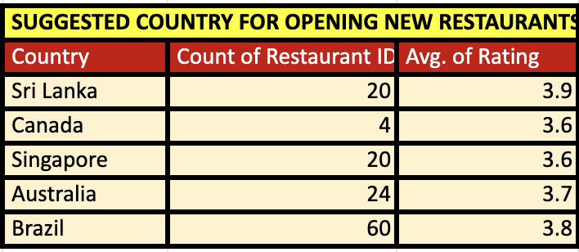
The Table and the Chart can be found in Sheet Name: Suggested Countries
This the specific table for the suggested countries along with Average rating and Count of Restaurants.
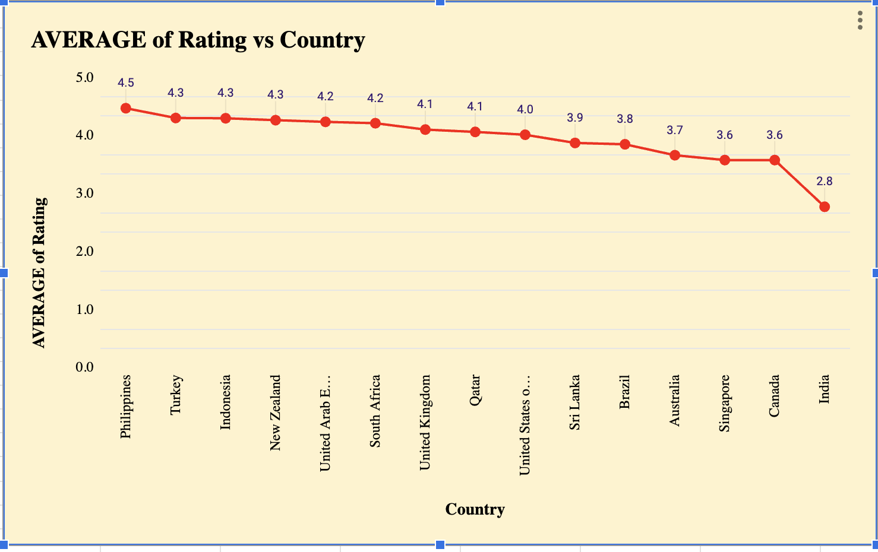
Visualization Technique: Clustered Column, Line with markers
RECOMMENDATION:
- Market Analysis: Perform detailed qualitative research in the top three recommended countries to understand the underlying reasons behind low customer ratings.
- Concept Creation: Develop a restaurant model tailored to the specific issues and preferences uncovered during the research.
- Pilot Launch: Begin with a small-scale trial outlet in the capital city of the highest-potential country to reduce upfront investment and make data-driven improvements.

- Come up with the names of States and cities in the suggested countries suitable for opening restaurants.

ANALYSIS AND APPROACH:
To suggest cities only (as we don’t have names of states) in the suggested countries suitable for opening restaurants, I have taken help of Pivot Table to analyze the situation. In the Pivot Table, I have taken the country and city in Row field. Count of restaurant ID, count of Has online delivery and average of rating, all 3 in the value field.

Suggested cities: Cities like Beech worth, East Ballerina, Huskisson and some others, which can be selected from Australia, Rio de Janeiro from Brazil, Vineland Station from Canada.

Also, other cities like Consort and Yorkton from Canada, Colombo from Sri Lanka and Singapore as chosen cities for opening new restaurants, as online delivery option is available with lesser count of restaurants and rating is also good.

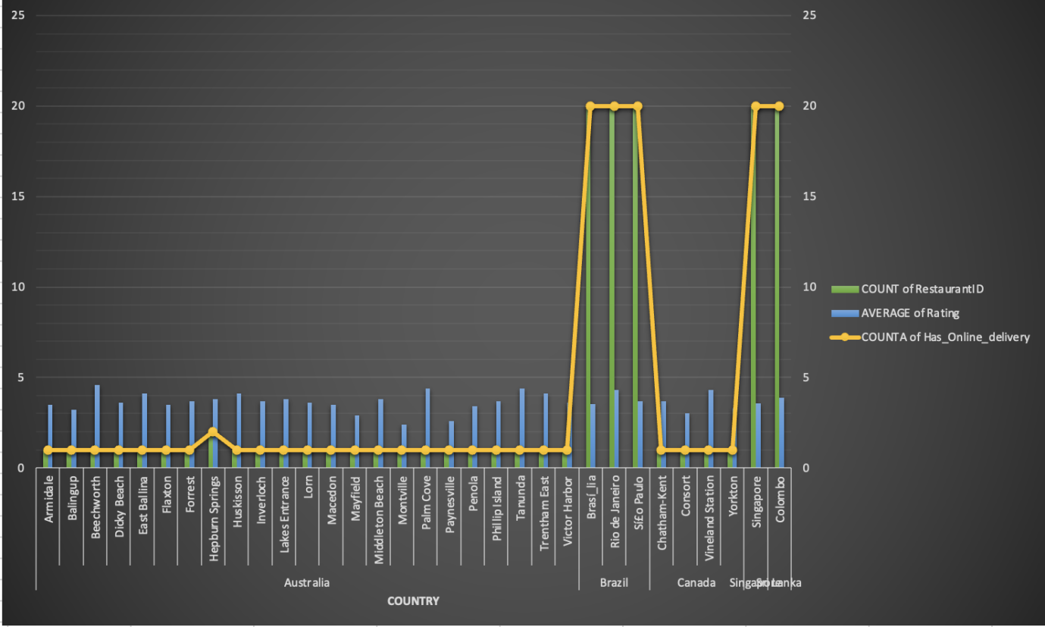
In Excel file, Sheet name: Suggested cities

RECOMMENDATIONS:

1. Australia: Elevate Quality in Regional & Tourist Locations

Recommendations:
Coastal/Tourist Areas (Dicky Beach, Huskisson, Phillip Island): Introduce a premium casual-dining concept with a strong local identity. Cater to tourists and affluent residents seeking a superior dining experience.

Regional/Inland Areas (Armidale, Macedon): Launch an all-day café that shifts into a refined dinner service. Prioritize quick service to meet the needs of students and working professionals.

2. Canada: Leverage Agri-Tourism in Vineland Station
Situated in the Niagara wine region, Vineland Station attracts food and wine enthusiasts.

Recommendations:
Establish a farm-to-table or artisanal concept supported by strong digital branding. Position it as a high-quality alternative to the current market offerings.

3. Singapore: Opt for a Cost-Efficient Cloud Kitchen
The market is highly competitive, expensive, and heavily reliant on food delivery platforms.

Recommendations:
Implement a delivery-focused cloud-kitchen model specializing in a niche cuisine (e.g., unique Asian regional dishes or health-focused meals) to avoid high real-estate and labor expenses.

4. Sri Lanka (Colombo): Tap Into the Rising Middle Class
Colombo shows growing demand for premium international and fusion dining, especially among urban youth.

Recommendations:

Introduce a full-service, mid-to-premium global cuisine restaurant with strong digital integration. Focus on superior quality to overcome the existing issue of low customer ratings.

5. Brazil (Rio de Janeiro): Strengthen Digital-First Dining
The Brazilian market relies heavily on delivery apps, and low ratings reflect poor digital order quality.

Recommendations:
Develop a high-volume QSR or casual dining brand optimized for delivery. Use a ghost kitchen or compact outlet in high-density areas to maximize efficiency and consistency.

- According to the countries you suggested, what is the current quality regarding ratings for restaurants that are open there?

APPROACH:
To analyse the current quality of ratings for restaurants that are operating there, I have first assumed Average Rating and Average _cost_for_two_INR as primary factors to check it.
Also, with the help of pivot table, I took the suggested countries on row and rating in the value. Changed the value to average and did same for average_cost
_for_two_INR.
Visualization technique which I used is the combo chart using clustered column and line marker to understand the relation between average ratings and average of average cost of two.

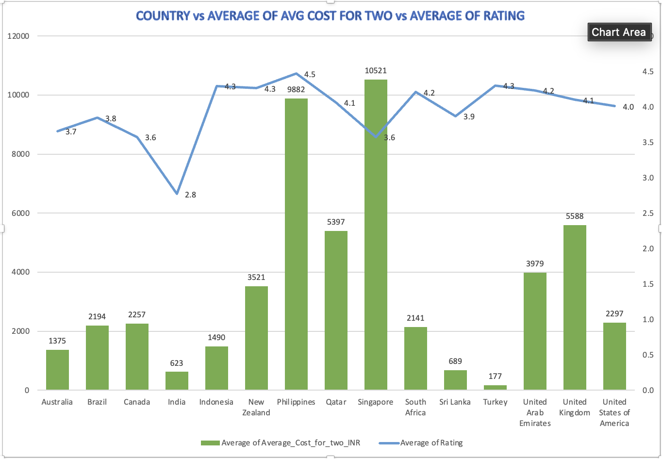
In Excel, sheet name : Quality Ratings
ANALYSIS AND RECOMMENDATIONS:
- All considered countries have average ratings ranging from 3.6 to 3.9, indicating generally good restaurant quality.
Sri Lanka leads with the highest rating of 3.9, suggesting a market with well-established, possibly upscale dining options or discerning customers.
- Canada and Singapore show the lowest rating at 3.6, which remains respectable on a global scale.
- Despite these differences, the overall positive trend across countries highlights a strong and consistent restaurant sector.
The slight variation in ratings points to opportunities for improvement in specific areas, such as service consistency or food execution, particularly in markets like Singapore.

- Also, what is the current expenditure on food in the suggested countries, so we can keep our financial expenditure in control?

APPROACH:
To find the financial sight of suggested countries and determine where opening new restaurants can be beneficial, I have analyzed it through the help pivot table. On the pivot table, I added count of Restaurant ID , average of price range and average_cost_for_two_INR in the value field. Along with that, I have also created the table called CALCULATED EXPENDITURE.

ANALYSIS OF EXPENDITURE:
Here, I calculated expenditure by using formula : Expenditure = Average_cost_for_two_INR * Count of Restaurant ID.
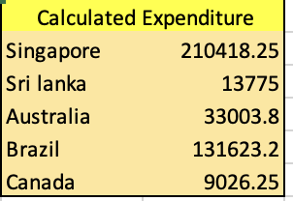
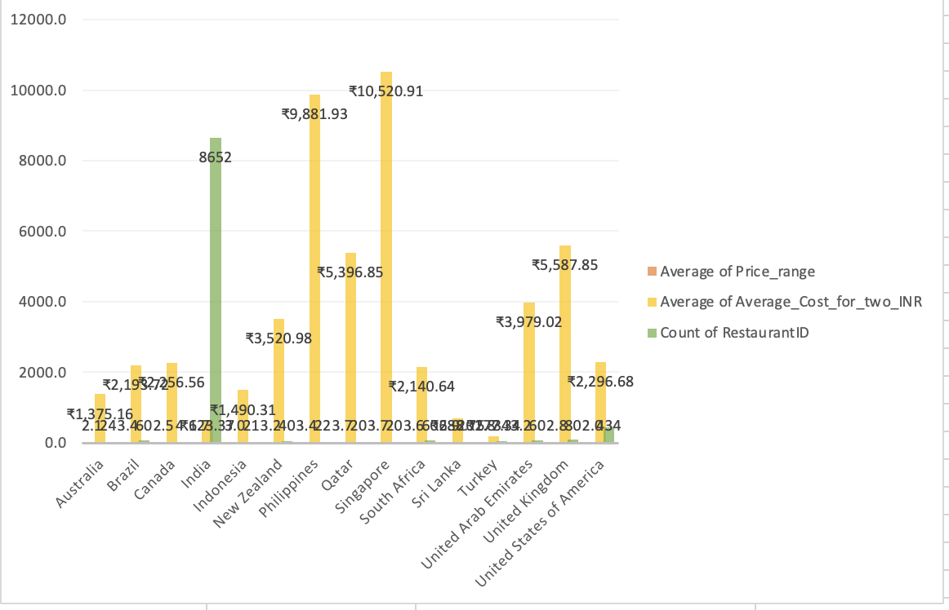
VISUALIZATION: I created a 2D column chart and pie chart given below.
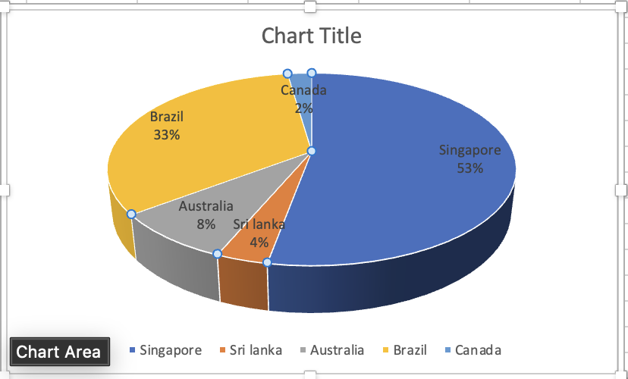
OBSERVATION:
Singapore dominated food spending with around 53%, accounting for the huge majority of total expenditure. And on the other hand, countries like Sri Lanka, Brazil, Canada contribute marginally, highlighting a bigger spending gap between countries.
KEY INSIGHTS:
1. Extreme Spending Disparity : Singapore accounts for most of the overall food budget due to its high average dining costs, larger number of restaurant suggestions, and expensive market conditions.
2. Financial Pressure Point: Decisions in Singapore largely determine total expenditure, while changes in Sri Lanka, Brazil, or Canada have little effect, making them low financial risk.
3. Value/Market Indication: Sri Lanka, Brazil, and Canada provide cost-effective dining options and allow more restaurant reviews per rupee spent, resulting in better ROI.
RECOMMENDATIONS:
- Budget Reallocation and Control:
Focus spending primarily on Singapore while limiting costs by capping the average meal price and the number of restaurant reviews.
Allocate minimal budgets for Sri Lanka, Brazil, and Canada.
- Strategic Dining Selection in Singapore:
Prioritize cost-effective options such as hawker centres and local eateries to reduce average expenses.
Limit reviews of high-end restaurants to only those necessary for the project.
- Adjusting Project Focus:
Increase the number of reviews in Sri Lanka, Brazil, and Canada to expand content at lower costs, helping balance Singapore’s higher spending.
In Excel, sheet name: Expenditure

- Come up with the names of restaurants from the recommended states that are our biggest competitors and also those that are rated in the lower brackets, i.e. 1-2 or 2-3.

APPROACH:
I have used a pivot table to analyze this. In the row section, Country (selected from the recommended ones) and restaurant name is there.
In the value field setting average of rating and average voters.
Based on ratings and votes, the competitors are evaluated.
[See pivot tables below]

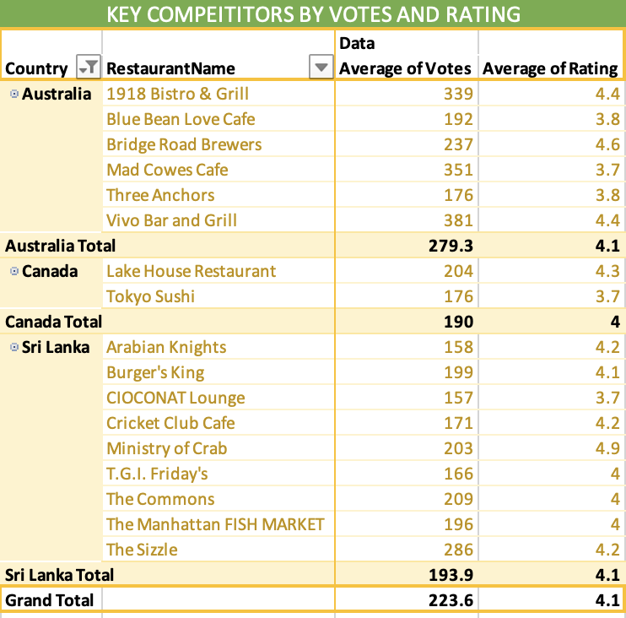
COMPETITORS AVAILABLE AND INSIGHTS:
The analysis highlights several top-performing restaurants across Australia, Canada, and Sri Lanka, with average ratings above 4.0 and high customer engagement (votes ranging from 150 to over 380). Notable competitors include Bridge Road Brewers, Vivo Bar and Grill, and Ministry of Crab, each demonstrating strong customer satisfaction and popularity. These restaurants represent key benchmarks for quality and experience within their regions, and should be closely monitored for competitive positioning.
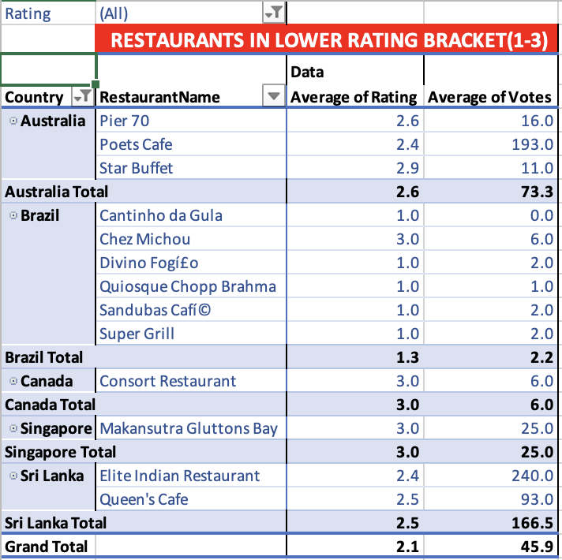

● Overall Quality Raises Concerns:

All restaurants included in this segment fall within the low satisfaction band (1.0 to 3.0), and the combined average rating is just 2.1 — signaling a generally poor customer experience level.

● Brazil Shows the Most Severe Performance Issues:
5 out of 6 Brazilian restaurants hold a rating of 1.0, highlighting a major gap in quality and consistency.This region requires urgent corrective action or stricter partner evaluation.

● Australia and Sri Lanka Reflect Mid-to-Low Performance:
Restaurants in Australia show ratings in the range of 2.6–2.9 with moderate vote volumes, indicating uneven service quality.

Sri Lanka also reports low ratings, though with higher customer participation (e.g., Elite Indian Restaurant with 240+ votes).

● High Votes but Low Satisfaction Levels:
Outlets such as Poets Cafe (Australia) and Elite Indian Restaurant (Sri Lanka) receive a significant number of votes, yet still maintain low ratings (2.4–2.6), showing consistent customer dissatisfaction over time.

RECOMMENDATIONS:

● Immediate Quality Assessment in Brazil:
Considering the high concentration of 1.0-rated outlets, Zomato should:

■ Conduct immediate partner evaluations
■ Consider delisting persistently poor performers
■ Introduce better-quality restaurants into the market

● Focus on High-Engagement yet Low-Rated Outlets:
Restaurants like Poets Cafe and Elite Indian Restaurant draw substantial customer attention but fail to deliver quality.
These outlets are strong candidates for improvement programs such as:

■ Staff upskilling
■ Menu improvements
■ Detailed service audits

● Strengthen the Mid-Performing Markets:
Both Sri Lanka and Australia may benefit from:

■ Carefully onboarding stronger restaurant partners
■ Highlighting any existing top-rated restaurants (4.0+) if present outside the filtered dataset

● Use This Group for Reputation Risk Monitoring:
Restaurants rated between 1 and 3 should be tracked closely through automated alerts. Continued negative experiences from this segment could harm Zomato’s overall brand reputation in international markets.

- Should the team keep the rate of cuisines higher? Will that affect the feedback? According to our data are the rates of cuisines and ratings, correlated?
APPROACH:
To analyse the circumstances that focus on cuisine preferences in the newer restaurants to get better feedback, I have taken the help of a chart visualisation: Line with Markers. In the chart, that defines the ratings of restaurants based on cuisines. I have also sorted each country's rating degree in descending order to showcase which food type is preferred most by the people of those countries.

ANALYSIS AND INSIGHTS:
After reading and examining the chart, I can say that the majority of Australian people prefer Pizza, Bar food, Mediterranean and Modern Australian Breakfast. On the other hand, people from Canada like Japanese and Sushi, Chinese and Italian. In Singapore, Bakery, American Streak is famous as well as Continental. Sri Lankan people extensively prefer Seafood, Juices and Desserts.

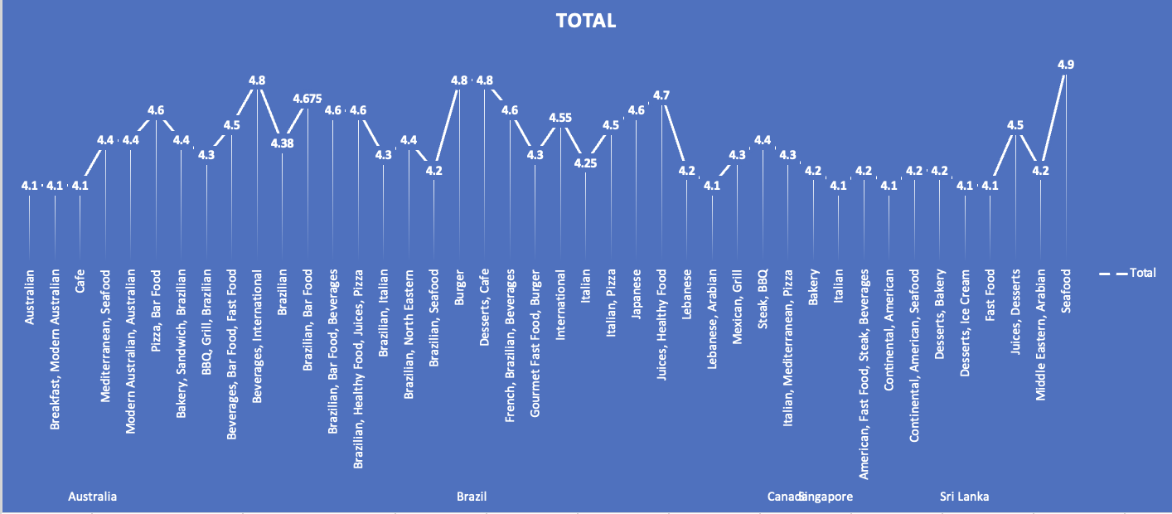
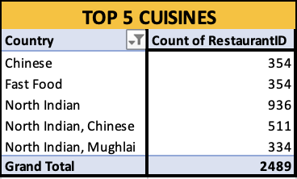
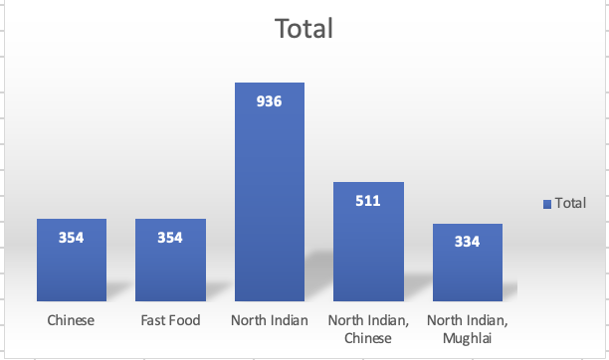
In the Excel file, sheet name : Analysing Cuisines
This visualization clearly shows that cuisine type has a noticeable impact on restaurant ratings. When expanding new restaurants across these highlighted countries, it would be beneficial to consider cuisine preferences during planning. Moreover, exploring cuisine categories that match rising food trends—such as plant-based options or farm-to-table concepts—could lead to stronger market acceptance and better performance.
RECOMMENDATIONS:
Restaurant Rating and Cuisine Type: Restaurant ratings are strongly correlated with cuisine types.
• Menu Strategy for New Restaurants: Prioritise popular local dishes to meet customer expectations and gain positive reviews.
• Emerging Food Trends: Introducing modern options like plant-based or farm-to-table dishes can attract a wider customer base.
- According to our current data, should we go for online delivery and table booking? Does that affect the customer’s ratings?
APPROACH:
To examine our current data and the decision whether we should go for online delivery and table booking, I have applied the COUNTIFS function, taken the country column and the has_online_delivery column and the has_table_booking column into consideration.
In the Excel file, Sheet name: Has online delivery
In my Zomato excel workbook, I have created a separate worksheet named has online delivery. Where I have created a table named Analysing Delivery and Booking availability.
My applied formula: =COUNTIFS ('1. Raw Data’! D:D,"Australia",'1. Raw Data'!L:L,"Yes")
[ for Australia > Has Online Delivery]
=COUNTIFS('1.Raw Data'!D:D,"Australia",'1.Raw Data'!K:K,"Yes")
[ for Australia > Has Table Booking]
A similar formula for both online and table booking for the remaining 4 countries is applied in the same way.
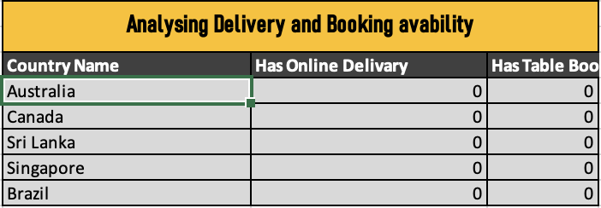
INSIGHTS AND SUGGESTIONS :
In my view, introducing an online delivery system and a table reservation feature in these recommended countries would be highly beneficial, as most restaurants there currently lack these services. It would also be useful to analyze whether the price for two correlates with the availability of delivery or reservation options, and to assess whether customers are willing to pay a premium for such conveniences. Offering these services could give us a strong competitive edge.

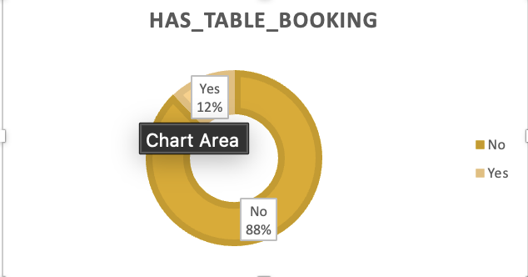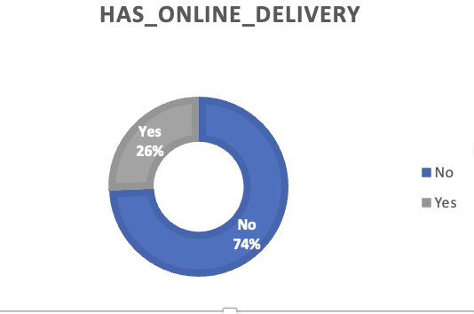
- Should the team keep the rate of cuisines higher? Will that affect the feedback? According to our data are the rates of cuisines and ratings, correlated?
APPROACH:
I created a pivot table in the sheet titled Correlation_betweenRC&CINR, where I filtered the recommended countries and placed their cuisine types in the row section. I selected the average rating and the average cost for two (INR) as the value fields. Afterwards, I used a scatter chart to visually display the relationship between these two metrics.
I have also used CORREL function: =CORREL (L4:L101, M4:M101)
To find the correlation between cuisine ratings and avg. cost for two INR.

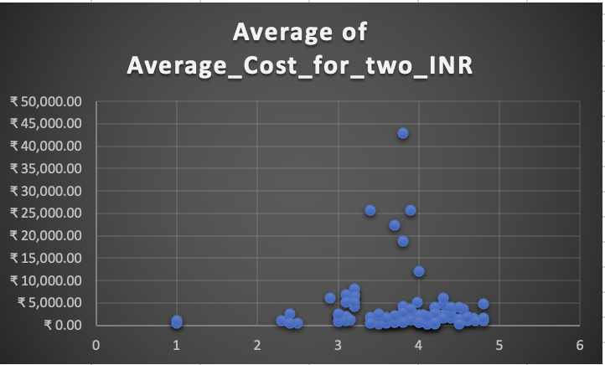
Visualization Technique used : Scatter Plot

In Excel file, sheet name: Correlation
The negative value in my correlation output indicates an inverse relationship. As restaurant ratings increase, the cost for two tends to drop noticeably, and vice versa. This suggests that setting competitive prices slightly lower than the highest-rated restaurants within the targeted cuisine can attract more customers—especially in price-sensitive markets—while still maintaining a strong sense of value.
SUGGESTIONS AND RECOMMENDATION:
The analysis clearly shows a positive correlation between the cuisine rating and the average cost (for two people). Higher-rated cuisines generally have a higher cost.
Maintain a Balance of Cost and Quality:
Strategic Pricing: Since higher ratings correlate with higher costs, the team should consider keeping the rate of high-quality (high-rated) cuisines higher to match customer expectations and cover the associated premium in ingredients, preparation, or ambiance.
Focus on Value: For mid-range or lower-cost options, the team should strive to offer the best possible quality/value ratio to ensure competitive ratings even at lower price points.
Use High-Cost Cuisines as a Premium Offering:
Maximize Profit from Highly Rated Cuisines: The team can use the high-rated, high-cost cuisines (e.g., those rated ) as premium offerings to attract customers willing to pay more for excellent feedback/quality. This will likely affect the feedback positively by delivering a high-end experience that justifies the price.

Investigate Low-Cost, High-Rating Anomalies:
Identify Best Practices: Look closely at any cuisines that have a high rating (e.g., ) but a lower-than-average cost. These anomalies represent excellent value for money. The team should analyse these options to replicate their success (e.g., efficient sourcing, unique preparation) across other menu items.
Transparency in Pricing:
Manage Expectations: Be transparent about the pricing structure. When increasing the price of a cuisine, ensure the quality, presentation, or portion size is noticeably improved to justify the higher rate and maintain good feedback. The positive correlation suggests customers are generally willing to pay more for better food.
- What is the distribution of the number of restaurants of different price ranges in all the countries?
APPROACH:
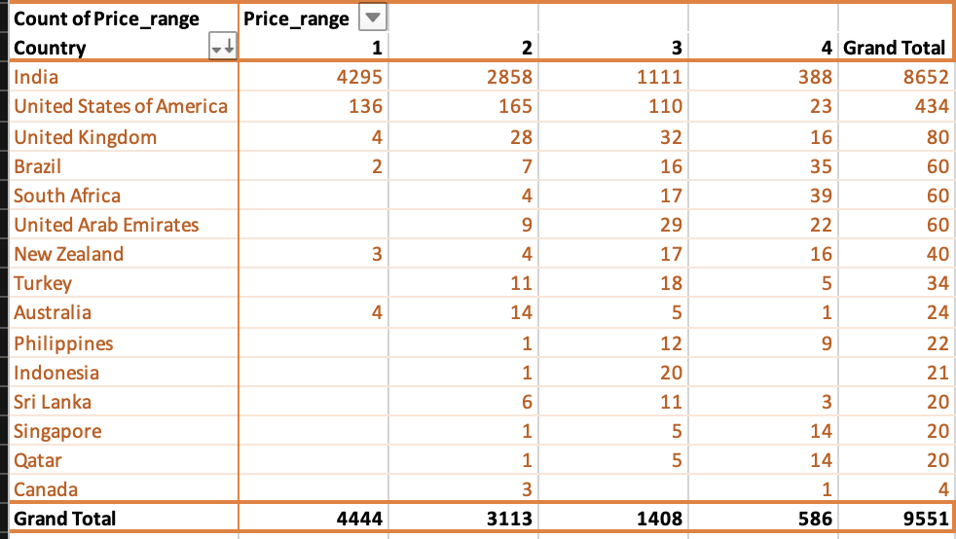
From this pivot table we see that India has the most restaurants with a wide range of prices, according to the PivotTable from which I have obtained assistance. Indonesia has the lowest ranking.
INSIGHTS:
India is by far the largest market in this dataset, with over 85% of its restaurants falling in the low to medium price ranges (1 & 2), showing strong demand for affordable dining options.
USA, UAE, and South Africa show a relatively more even distribution, but still lean toward price ranges 2 and 3, suggesting a mix of budget and mid-tier dining preferences.
Countries like Australia, UK, Singapore, and Canada show a higher presence of mid-to-premium restaurants than low-cost options, indicating a target audience with higher disposable income or more premium expectations.
Some countries (e.g., Qatar, Turkey, Indonesia) have minimal restaurant representation, but their few listings lean toward higher price brackets — potentially untapped or niche markets.
RECOMMENDATIONS:
In India and Brazil, Zomato should continue strengthening its partnerships with budget-friendly restaurants by:
Offering combo deals, loyalty programs, and affordability filters.Promoting these restaurants through price-sensitive campaigns (e.g., “Best under ₹500”).
In USA, UAE, UK, and Australia, where premium and mid-tier restaurants are more common:
- Highlight premium listings with quality ratings, chef specials, or ambience tags.
- Introduce premium membership options offering table bookings, exclusive discounts, or curated picks.
For countries with low presence (e.g., Indonesia, Qatar, Sri Lanka), Zomato could:
- Conduct market feasibility studies to explore restaurant onboarding opportunities.
- Launch pilot marketing campaigns to attract local restaurants and understand pricing patterns.

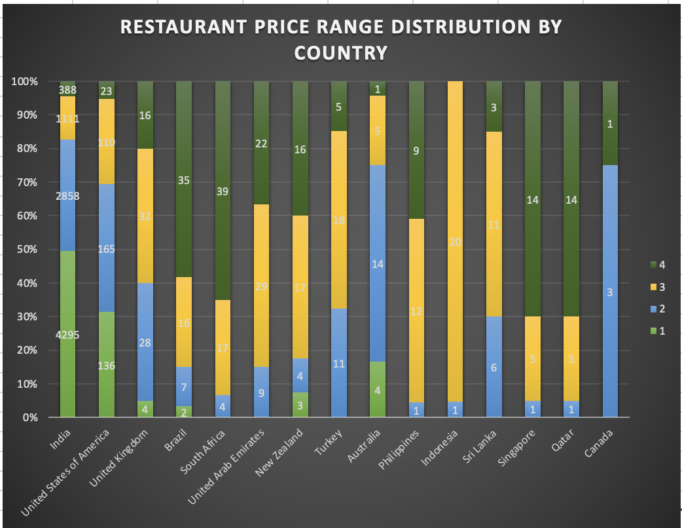

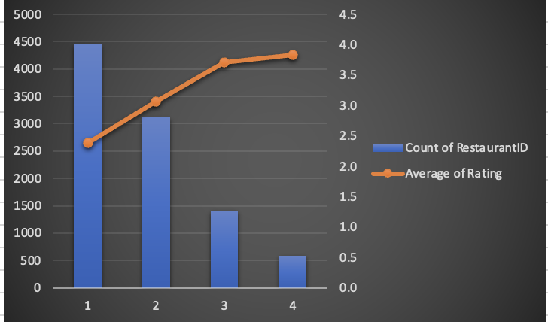

IN EXCEL FILE, SHEET NAME: PRICE RANGE

- Explain your approach in brief for suggesting countries/cities in order to open new restaurants, if the objective and subjective questions would have not been given to assist you. [you have to give bullet pointers in order to answer this question]
APPROACH:
Some approaches I would consider for suggesting countries or cities for opening new restaurants, even if the objective and subjective questions weren’t provided:
● New Restaurants:
By analyzing the variety of cuisines in each country along with their respective ratings, it is possible to identify countries with limited cuisine options and low overall ratings.
Focusing on opening new restaurants in countries with untapped potential and favorable competitive landscapes—such as Brazil, Australia, and Sri Lanka—could be highly effective. Within these countries, prioritizing cities with lower restaurant density would optimize market entry and reduce direct competition.

● Biggest Competitors:
A high number of voters in certain countries indicates strong consumer engagement with restaurants in those regions. This suggests a thriving market and a solid customer base, making these areas promising for new restaurant operations.
Analyzing such data helps identify major competitors and understand the strategies of market leaders. This insight can guide differentiation strategies for new restaurants, such as offering unique cuisines, superior service, or innovative dining experiences.

● Cost vs. Rating Analysis:
Examining the correlation between average dining cost and ratings can help pinpoint markets where both metrics are low. Regions with high costs but low ratings highlight gaps where affordable, better-rated restaurants could gain a competitive advantage.

● Cuisine Diversity & Ratings:
Countries with limited cuisine variety and low ratings present opportunities to introduce diverse, high-quality dining options to meet unmet customer demand.

● Customer Engagement:
Regions with a high number of voters and active ratings reflect strong user engagement, indicating a robust and interactive customer base. These markets can provide valuable insights for targeted marketing and service improvements.

THANK YOU!

